**To the kind attention of:** **Mr. Shaiju**

Project Manager

Qatar

**Subject:** Proposal for My Community Application

Dear Sir,

Please find enclosed our proposal for your kind consideration. Referring to your inquiry and based on the discussions, we are pleased for having the opportunity in submitting our best proposal as follows

* My Community Application project will be developed using React JS
* User Interface and API integrations will be the scope of development.
* Based on the requirements shared (35 Screen designs provided in google drive plus associated pop-ups, API documentation, and source code), development will start and code delivery would be on weekly basis.

I trust that below proposal fulfils your requirements. Please do not hesitate to contact me if I can be of any further assistance. Awaiting final confirmation to proceed further.

Thanks, and Best Regards

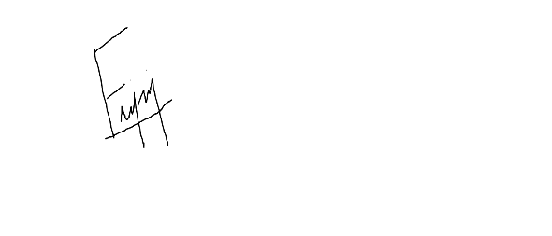

**Fijo John**

**TABLE OF CONTENTS**

**Page**

1. **PROJECT BUDGET** ……………………………………………………………3
2. **PROJECT TIMEFRAME**……………………………………………………….3

**3. PROJECT MILESTONE**………………………………………………………..3

**4. PAYMENT SCHEDULE**…………………………………………………………4

**5. TERMS AND CONDITION** …………………………………………………….4

**6. BANK PAYMENT**…………………………………………………………………5

**7. ACCEPTANCE OF PROPOSAL**……………………………………………….5

1. **PROJECT BUDGET**

|  |  |  |  |
| --- | --- | --- | --- |
| **SL No.** | **Description** | **Rate** | **Total Amount** |
| 1 | Screen Designing using React JS Works, API Integration and Testing | ₹ 1,10,000 | ₹ 1,10,000/- |
| **Rupees One Lakh Ten Thousand only** | | | **Total: ₹ 1,10,000/-** |

1. **PROJECT TIMEFRAME**

|  |  |  |  |
| --- | --- | --- | --- |
| **SL No.** | **Work Description** | **No of resources**  **working** | **No of days required** |
| 1 | Designing, API Integration and Testing | 3 | 25 days (Maximum) |

1. **PROJECT MILESTONE**

|  |  |  |
| --- | --- | --- |
| **SL No.** | **Date** | **Description** |
| 1 | 03-May-2021 | Project Starts |
| 2 | 30-May-2021 | Project Delivery |

1. **PAYMENT SCHEDULE**

|  |  |  |  |
| --- | --- | --- | --- |
| **SL No.** | **Description** | **Payment terms** | **Amount** |
| 1 | Weekly, based on the number of pages delivered. | 25 % of the order value as advance | ₹27,500/- |
| 2 | Weekly, based on the number of pages delivered. | 25 % of the order value as advance | ₹27,500/- |
| 3 | Weekly, based on the number of pages delivered. | 25 % of the order value as advance | ₹27,500/- |
| 4 | At that time of Project Delivery | Remaining 25 % of the order value | ₹27,500/- |
| **Total: ₹ 1,10,000/-**  **Rupees One Lakh Ten Thousand Only** | | | |

**Additional Pages**

|  |  |  |
| --- | --- | --- |
| **SL No.** | **Description** | **Amount** |
| 1 | Additional 10 Pages other than our initial Plan, based on pro-rata. | ₹30,000/- |
| **Total: ₹ 1,40,000/-**  **Rupees One Lakh Forty Thousand Only** | | |

1. **TERMS AND CONDITIONS**
2. All pricing provided is exclusive of applicable taxes.
3. Payments received are not reimbursable.
4. Any workflow changes and additional scope shall be chargeable as extra at actuals
5. We are not providing any support once the project is delivered.
6. We will provide the developed pages for review and confirmation on weekly basis.
7. Payments will be on weekly, based on the delivery of pages.
8. **BANK DETAILS**

* Bank Name :- SOUTH INDIAN BANK
* A/C No :- 0646053000004207
* IFSC Code :- SIBL0000646
* Account Name:- Greety Jose

1. **ACCEPTANCE OF PROPOSAL**

To proceed with this project, organisation’s authorised representative is required to email a Purchase Order to fijojohn27@gmail.com which includes the following details and information:

* Your unique PO # (we will reference this number on all of our invoices)
* Proposal Title: My Community Application (Web) Proposal

Each party acknowledges it has read and understood this agreement and agrees to be bound by its terms.

|  |  |
| --- | --- |
| **Vendor:** | **Client:** |
| Signature | Signature |
| Name **Mr.** **Fijo John** | Name **Mr. Shaiju** |
| Title Project Coordinator | Title Project Manager |
| Date 23/05/2021 | Date 23/05/2021 |